JEREMIAH NYAGAH NATIONAL POLYTECHNIC

ELECTRICAL AND ELECTRONICS DEPARTMENT
AUTOMATE AN ELECTRICAL MACHINE

ASSESSMENT II

TIME: 2 HOURS

75 MARKS

Qualification Code: 071306T4EEN
Qualification: Electrical Engineering Level 6
Unit Code: ENG/OS/PO/CR/05/6
Unit of Competency: Automate an electrical machine

INSTRUCTIONS
- Attempt all questions in Section A and B.
- Marks for each question are indicated.

SECTION A (35 MARKS)
- Define automation. Give TWO real-life examples. (2 Marks)
- List FOUR components of an automation system and describe their functions. (4 Marks)
- Differentiate between open loop and closed loop control systems with examples. (3 Marks)
- What are microcontrollers, and how do they differ from PLCs? (3 Marks)
- List and briefly describe any THREE programming languages used in industrial automation. (3 Marks)
- Define the term "simulation" in the context of automation systems. (2 Marks)
- What is the role of configuration in automation systems? (2 Marks)
- Explain TWO safety precautions to observe when testing an automation system. (2 Marks)
- What is debugging in automation programming? Provide an example. (3 Marks)
- What are test parameters in automation systems? Name THREE and explain their importance. (4 Marks)
- Describe the steps taken to record and interpret test values from an automated system. (4 Marks)
- Explain the importance of system efficiency tests. (2 Marks)
SECTION B (40 MARKS)
- A checkweigher stationed at Kathangariri tea factory consists of an infeed conveyor, middle conveyor with a load cell, and an output conveyor with a pneumatic rejector as shown in figure 1. A product present sensor is mounted on the infeed conveyor that detects the product.
- When a product passes over the middle conveyor, the load cell records the weight of the product during its travelling and sends signals to the PLC. The PLC receives three types of signals from the load cell (High weight, low weight, and accurate weight).
- If the product's weight is OK, the product will pass from the checkweigher.
- But if the product's weight is low or high, a pneumatic rejector will reject the product from the outfeed conveyor.
- If products are rejected 5 times, then a red lamp will glow.
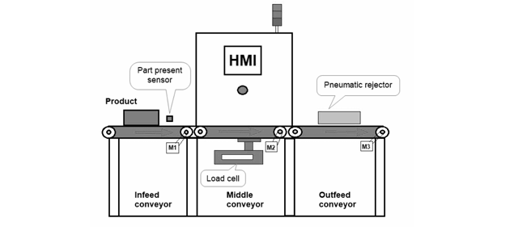
Fig 1
a) Draw the wiring diagram (6 Marks)
b) program the system using ladder language (10 Marks)
c) How would you ensure all safety standards are adhered to? (4 Marks)
- A manufacturing line requires system upgrades.
a) Explain how you would program the automation system for maximum efficiency.
(8 Marks)
b) List and describe four methods for testing system parameters. (8 Marks)
c) What documentation is essential post-testing and how is it used? (4 Marks)

